Spatial Resolution
Code:
import cv2
import numpy as np
import matplotlib.pyplot as plt
from scipy.signal import find_peaks
custom_image = cv2.imread('sarac.jpg', cv2.IMREAD_GRAYSCALE)
plt.imshow(custom_image, cmap='gray')
plt.show()
if custom_image is not None:
line_sum = np.sum(custom_image, axis=0)
peaks, _ = find_peaks(line_sum, height=0.5)
peak_distances = np.diff(peaks)
mm_per_image = 10
pixels_per_mm = custom_image.shape[1] / mm_per_image
spatial_resolution = pixels_per_mm / np.mean(peak_distances)
print(f"Spatial Resolution: {spatial_resolution:.2f} LP/mm")
else:
print("Görüntü yüklenemedi veya geçerli formatta değil.")
Code Explanation:
- Image Loading: The image 'sarac.jpg' is read in grayscale using OpenCV (cv2.imread).
- Image Display: The image is displayed using Matplotlib (plt.imshow).
- Checking Image: It checks if the image was loaded successfully.
- Summing Vertical Pixels: The pixel values along the vertical axis (columns) of the image are summed.
- Finding Peaks: The find_peaks function identifies significant intensity peaks in the summed vertical profile, representing edges or patterns.
- Calculating Peak Distances: The distances between consecutive peaks are calculated.
- Spatial Resolution: The spatial resolution is estimated by dividing the pixel density by the average peak distance. This gives the resolution in line pairs per millimeter (LP/mm).

Output:
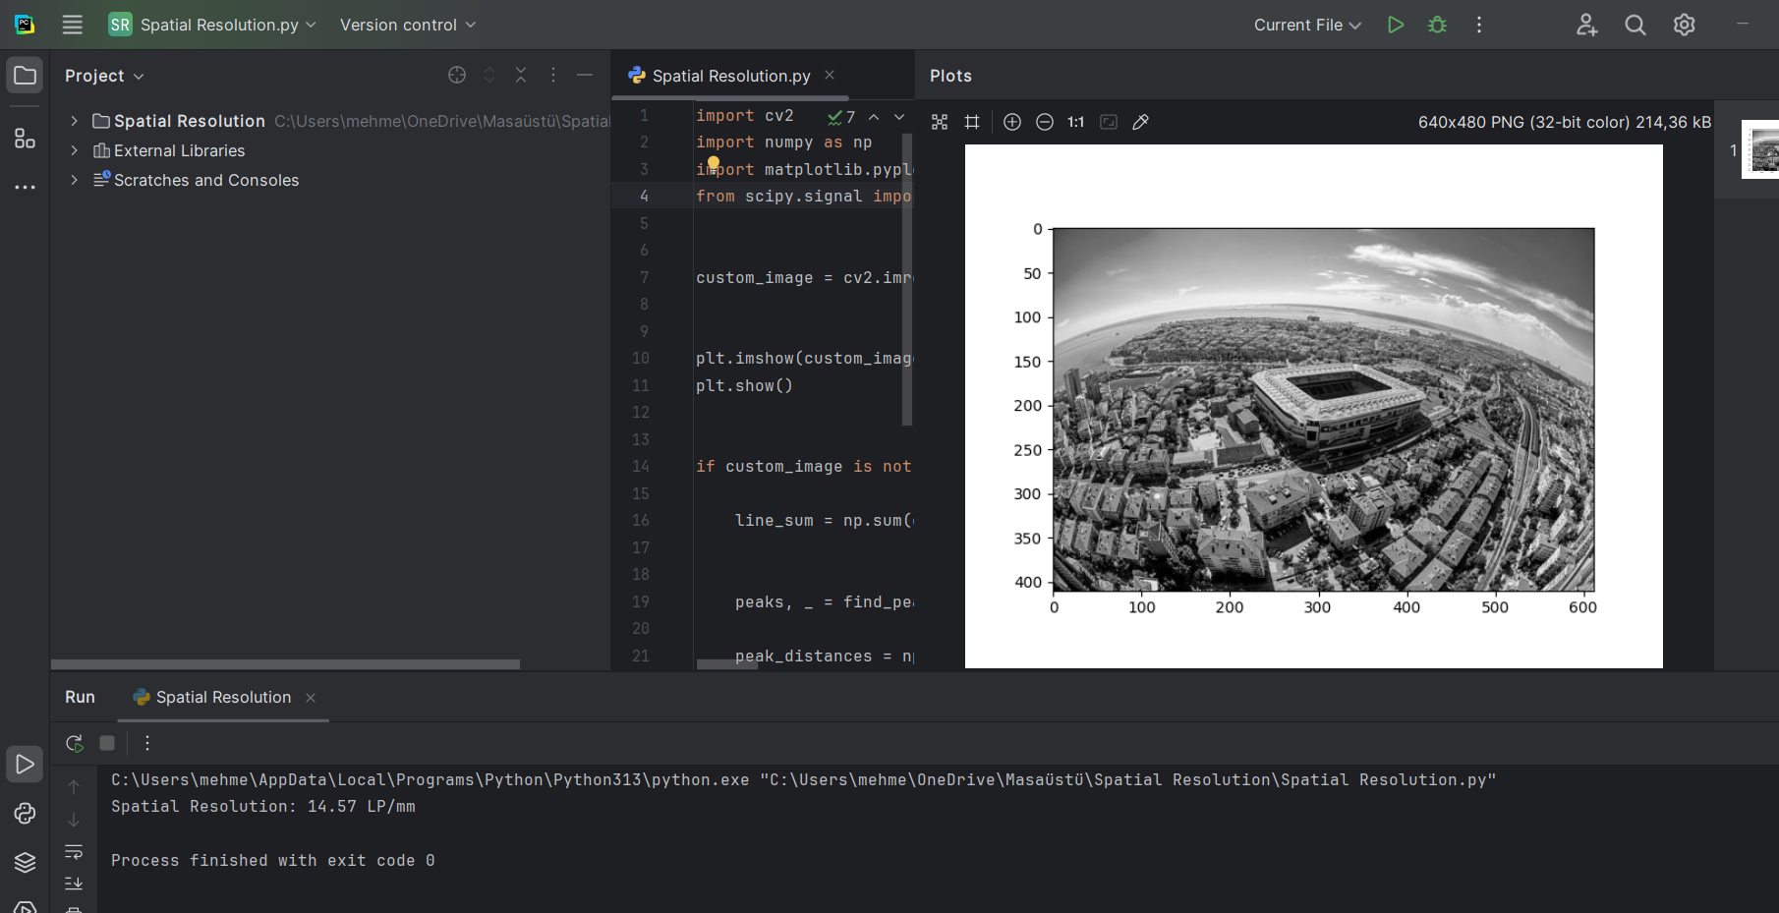

Report
This code calculates the spatial resolution of an image by detecting the periodic patterns (peaks) in its vertical pixel sum. The final result is printed as a spatial resolution value in line pairs per millimeter (LP/mm), which indicates how fine the image's details are.

